|  |  |
| --- | --- |
|  | **VIỆN ĐÀO TẠO QUỐC TẾ FPT**  **LẬP TRÌNH VIÊN QUỐC TẾ** **FPT - APTECH** |

**Địa chỉ: 590 Cách Mạng Tháng Tám, P.11, Quận 3, TP. Hồ Chí Minh.**

**Điện thoại: (08) 3 846 0846 - (08) 7300 8866**

**TechLine**

***TÀI LIỆU BỔ SUNG***

Giáo viên hướng dẫn : **PHAN MINH TÂM**

Lớp : **F2-13-1604-T0**

Nhóm : **05**

Thành viên nhóm :

|  |  |
| --- | --- |
| **Họ Tên** | **Mã Số** |
| Nguyễn Thế Huân | Student932536 |
| Nguyễn Minh Tiến | Student924965 |
| Cung Đình Uy | GC60506 |
| Trần Khánh Vương | Student924994 |

***Tháng 12– 2017***

**🙢🙡🟑🙣🙠**

**REVIEW III**

**Screenshot**

* 1. **Users**
     1. **Login**

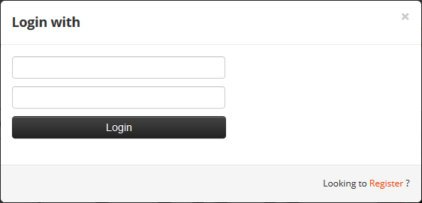

* + ***Description:***
* Link: home.jsp
* This is page user use to login.
* After login, redirect to Homepage.
  + ***Validation:***
* Username have 4-30 characters, no special characters.
* Password have 5-20 characters
  + 1. **Register**

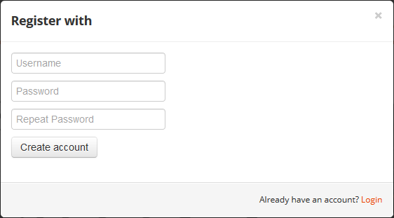

* + ***Description:***
* Link: home.jsp
* This is page user use to register an account.
* Link : redirect to Login dialog.
  + ***Validation:***
* Username have 4-30 characters, no special characters.
* Password have 5-20 characters.
* Repeat password must be the same with password
  + 1. **Manage Account**

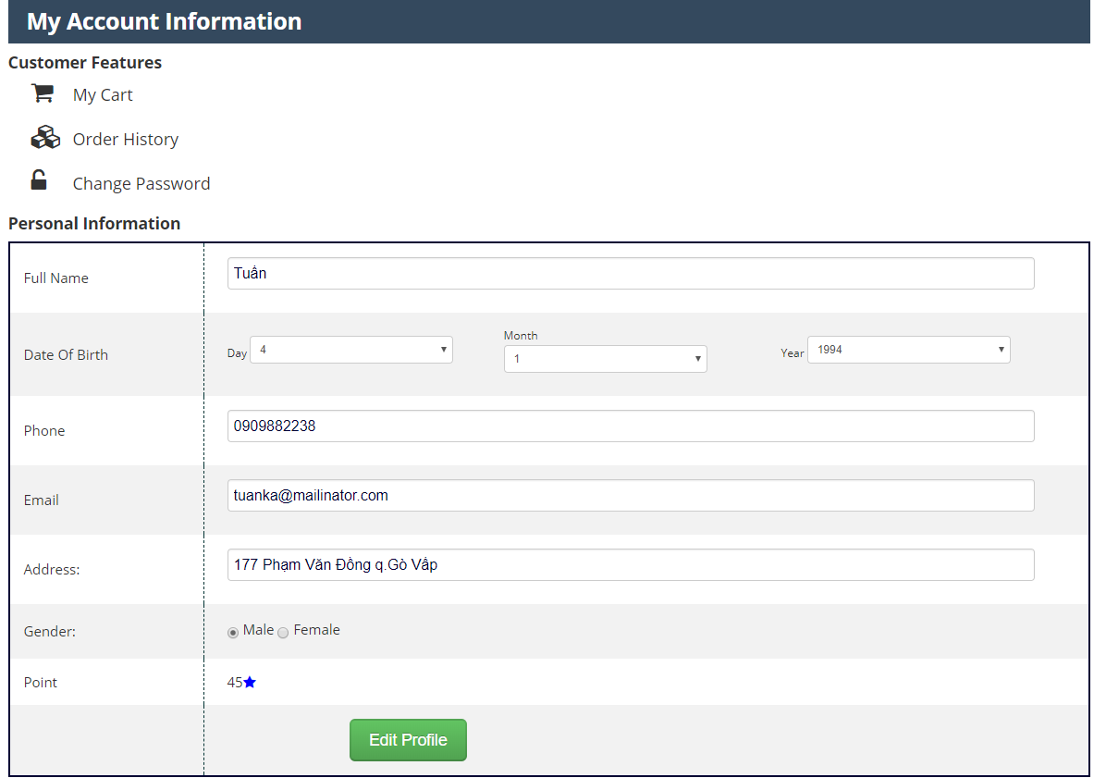

* + ***Description:***
* This is page user use to manage their account.
  + ***Validation:***
* Full name must have 1 characters or more.
* Phone have 9-15 digits.
* Email must be valid format.
* Address have 1-1000 characters.
  + 1. **Update Password**

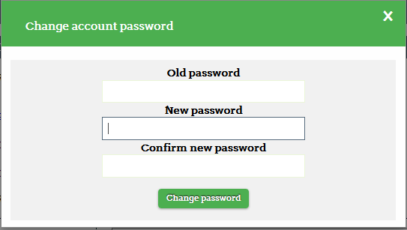

* + ***Description:***
* This is page user use to update password
  + ***Validation:***
* Old password and New password have 5-20 characters.
* Confirm password must be the same with New password.
  + 1. **Manage Order**
       1. **Order List**

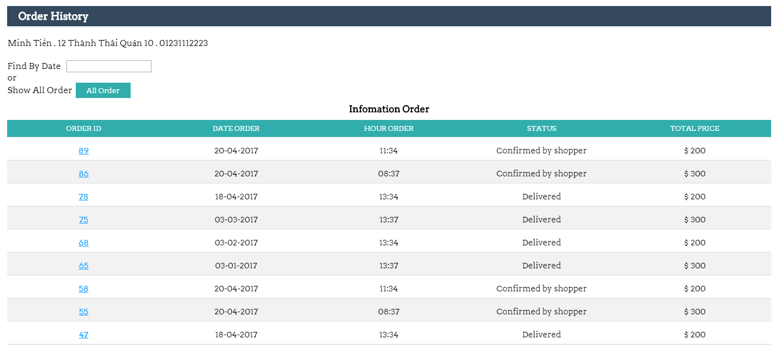

* + ***Description:***
* This is page user use to view orders list.
* User can view order history.
* User can click to “order id” to view order detail.
  + - 1. **Order Details**

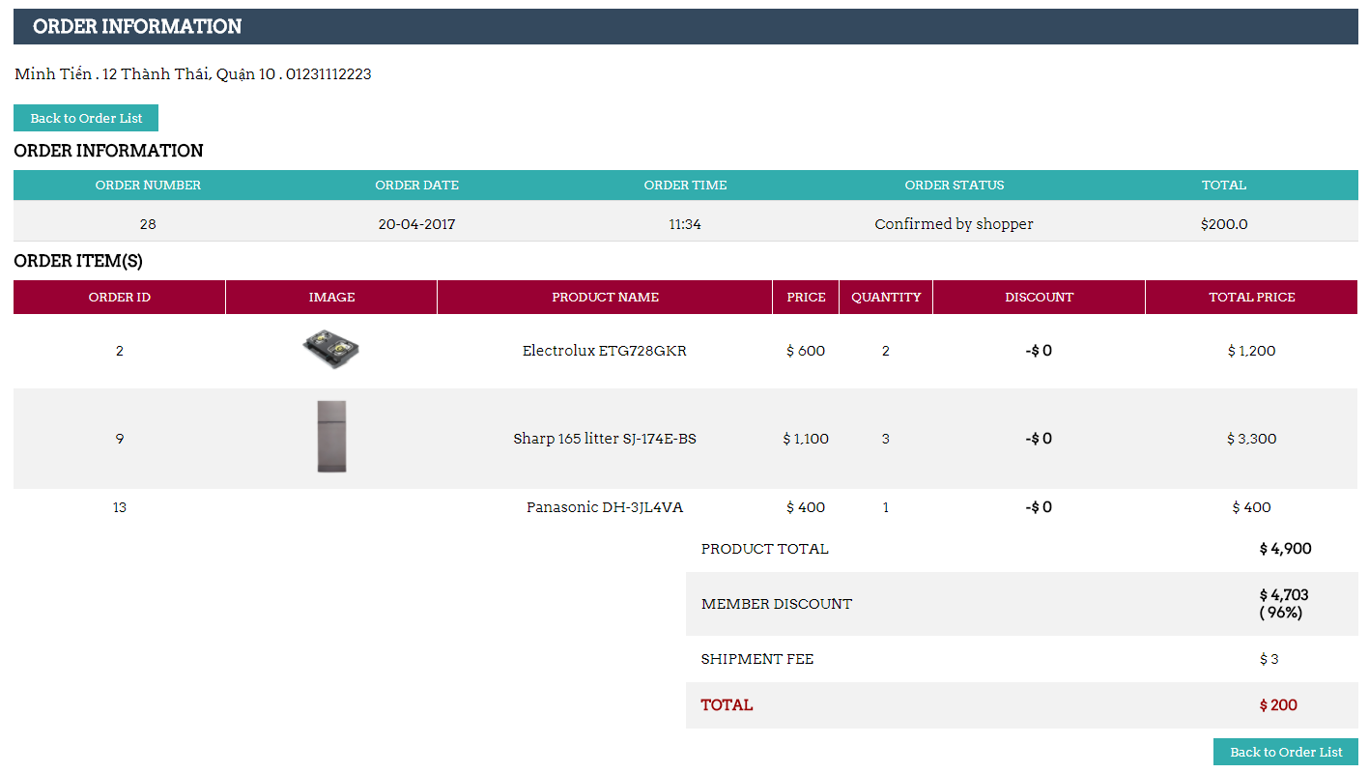

* + ***Description:***
* This is page user use to view and cancel order.
* User can view order detail.
* User can cancel order.
  + - 1. **Order Delivery**

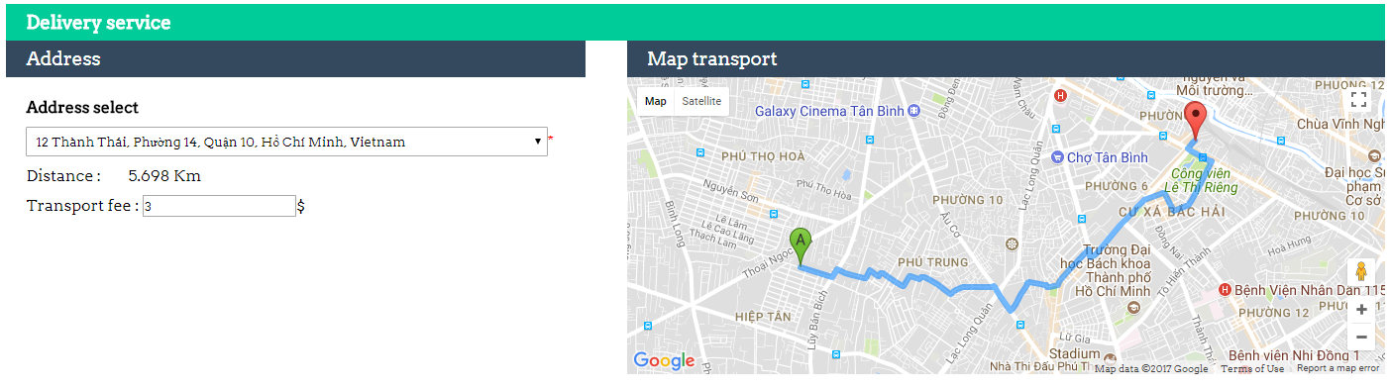

* + ***Description:***
* This is page user use to view delivery route and fee.
* User can view delievery route through google map and fee.
  + 1. **HomePage**

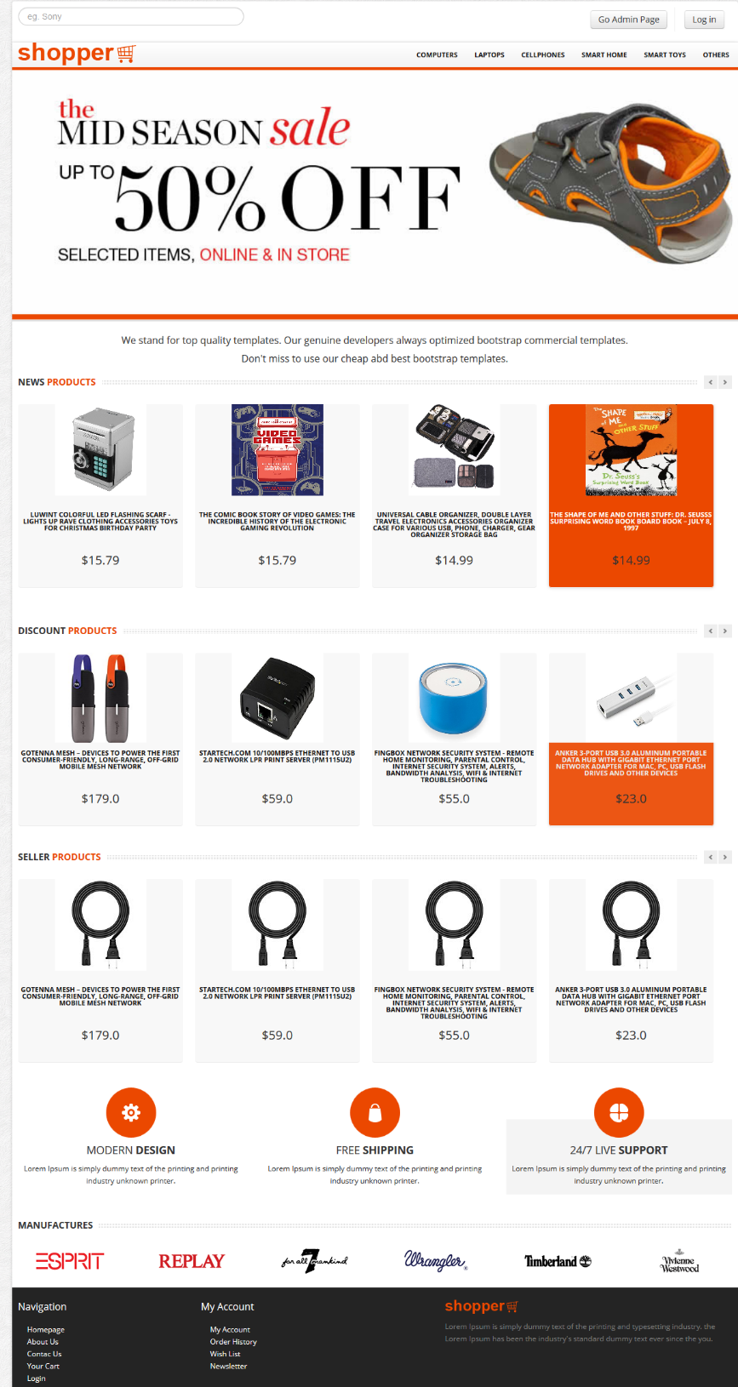

* + ***Description:***
* This page is default page when guest visit website and the page appear when user is logged in.
* User can view product, category.
* User can click product to view product detail.
  + 1. **Search Product**

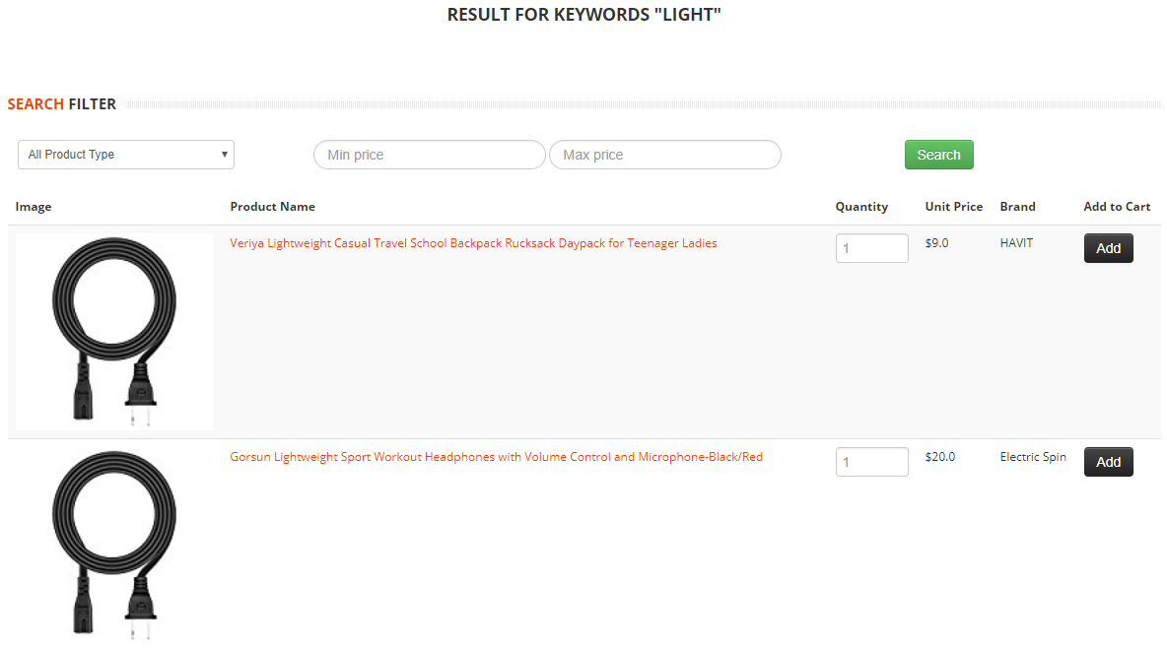

* + ***Description:***
* This page used for searching product.
* When users type keywords related to products into the search box and enter, this page appears.
  + ***Validation:***
* Min must be greater or equal 0.
* Max must be greater min and 0.01.
  + 1. **View Product Detail**

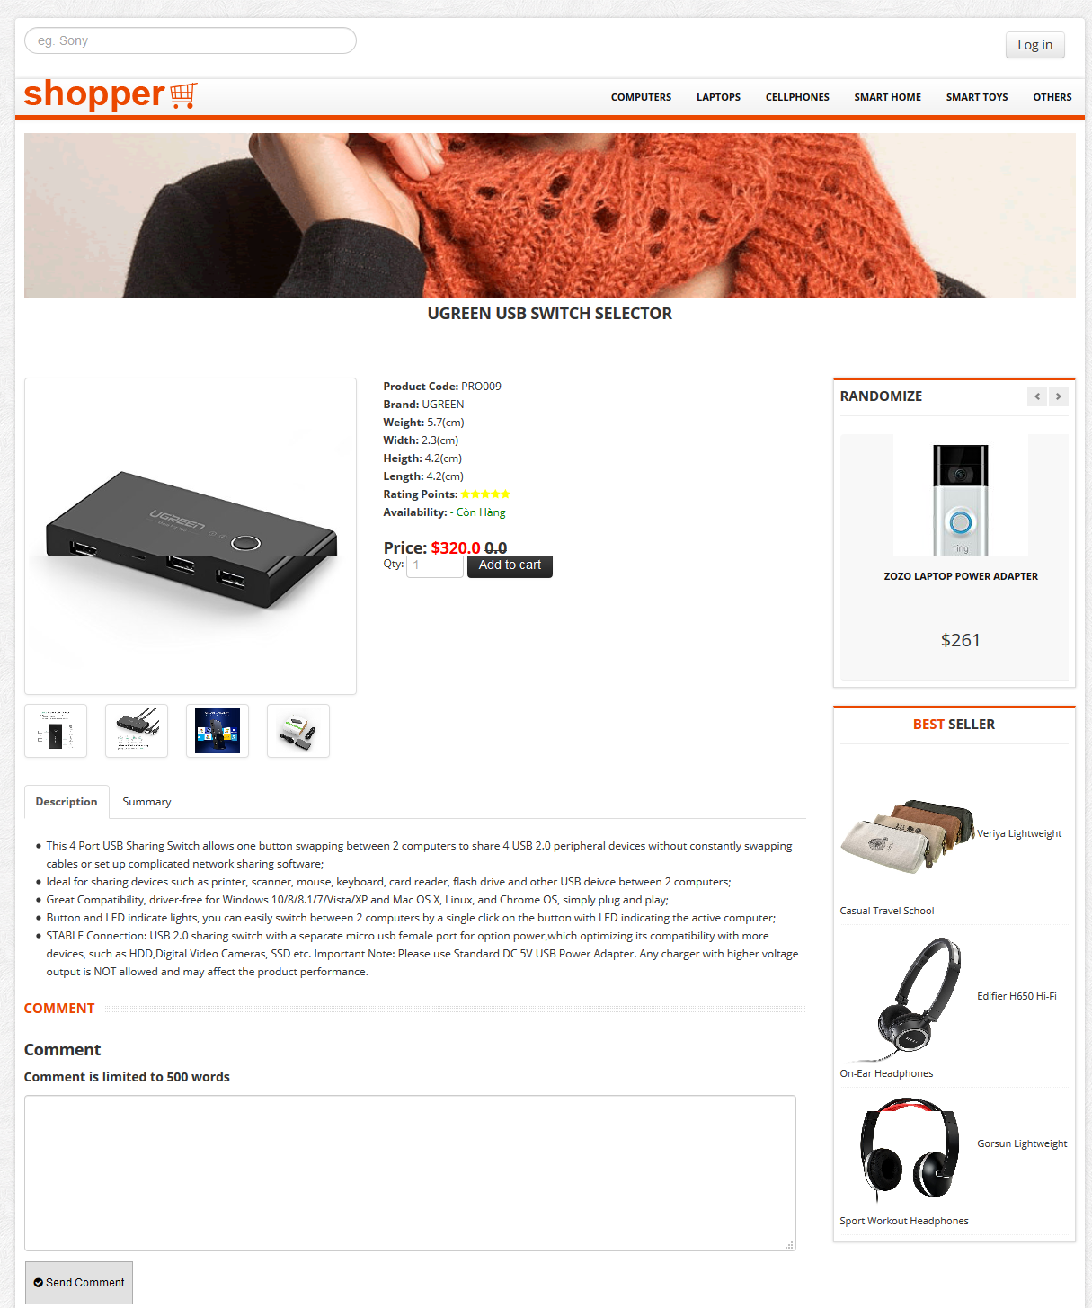

* + ***Description:***
* This page is the page to view product detail.
* User can view product detail.
* User can click “Add to cart” button to add product to cart.
* User can comment and rate product.
  + 1. **View Cart**

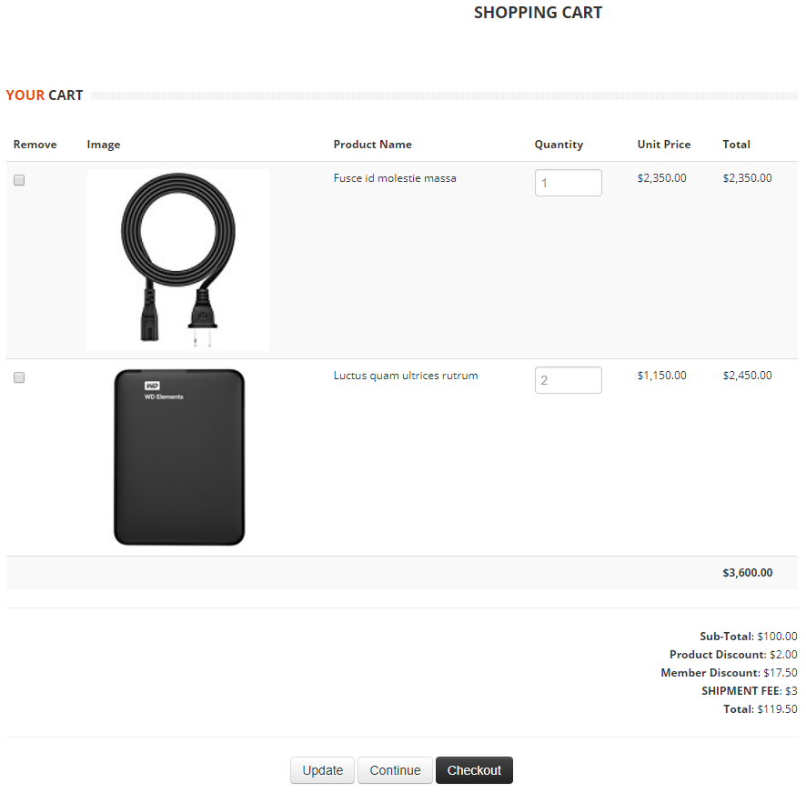

* + ***Description:***
* This page is used for checkout.
* User can view order detail.
* User can edit the number of each product in cart.
* User can remove product from cart
* User can confirm this order. After confirming, successful order notification appears.

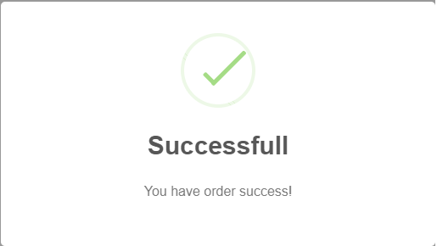

* 1. **Admin**
     1. **Manage User**

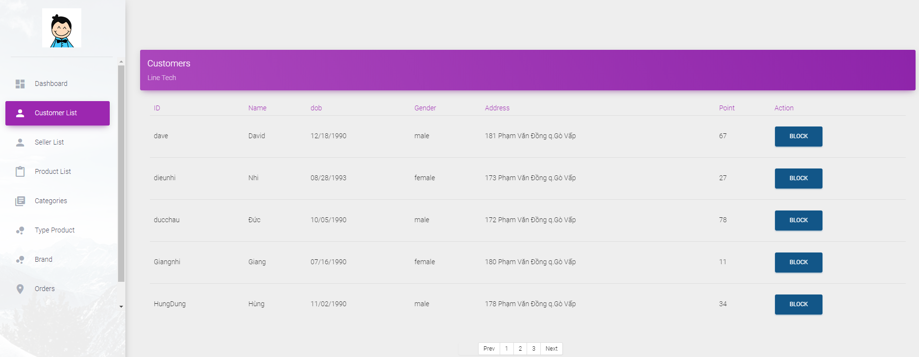

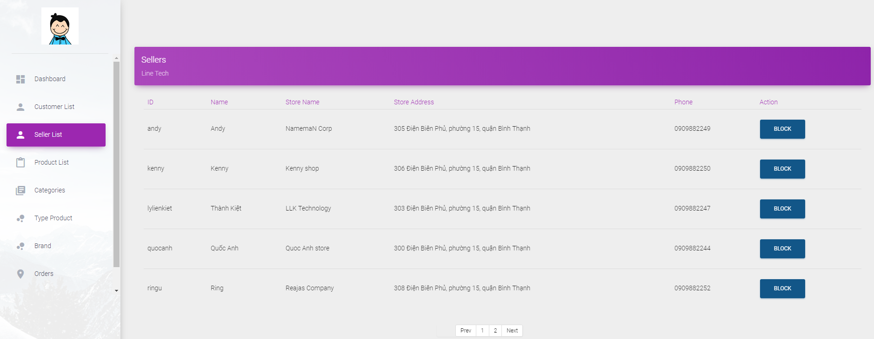

* + ***Description:***

- This is the page admin use to manage customers and sellers account.

* Admin can view customers/sellers information.
* Admin can block/unlock customers/sellers account.
  + - * 1. **Manage Product**
        2. **View , change product status**

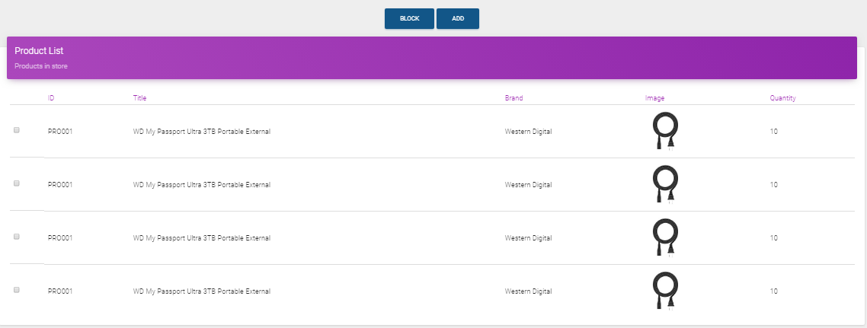

* + ***Description:***
* Link: admin/product.jsp
* This is the page admin use to manage product.
* Admin can view product information.
* Admin can block/unlock product.
  + ***Validation:***
* Unblock product: If Type/Brand of product is blocked, can not unblock product. Admin must unblock or change Type/Brand before unblock product.
  + - 1. **Add a new product**

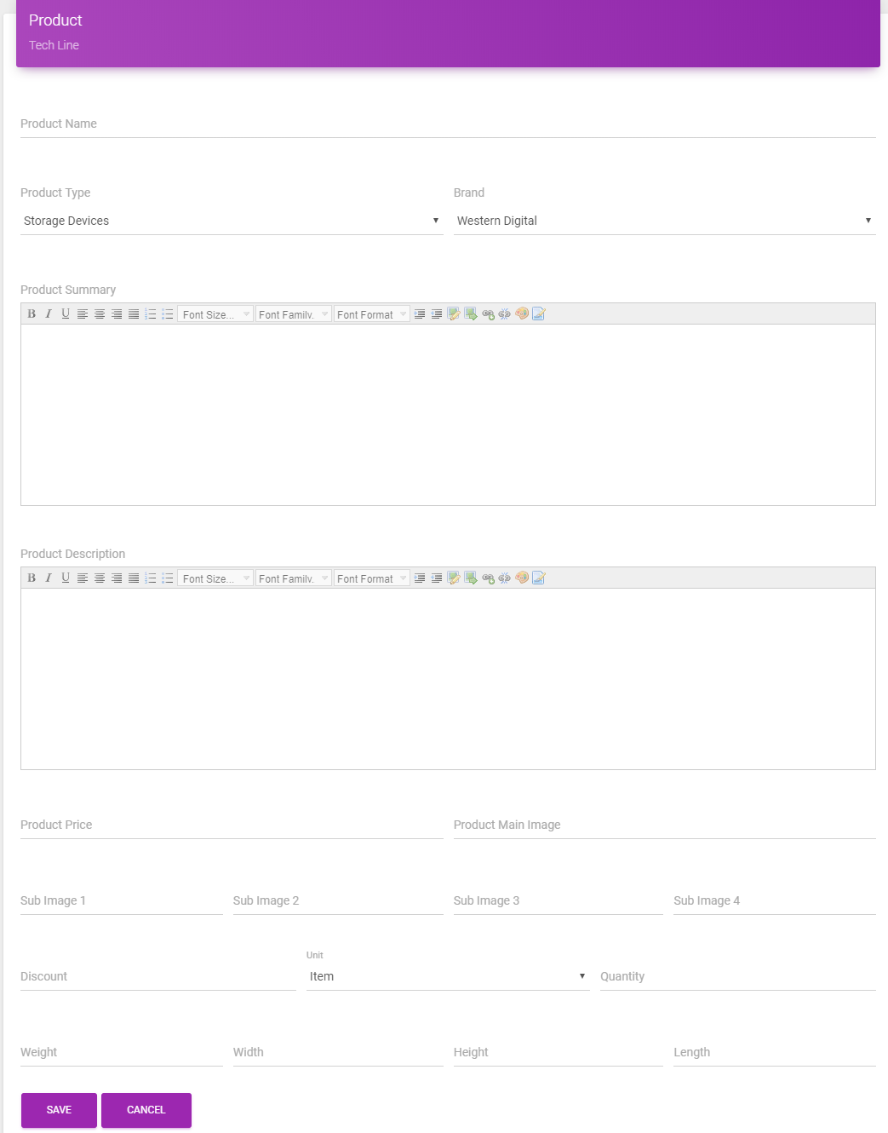

* + ***Description:***
* Link: admin/addProduct.jsp
* This is page admin use to add a new product.
* Weight unit is kilogram
* Width, height, length unit is centimeter.
  + ***Validation:***
* Product name have 1-500 characters.
* Product Type, Brand selected from the list.
* Product Sumary can not be empty.
* Product Discount must be a number, from 0 to 100. (%)
* Price must be decimal number, min 0.01 and max 10000.
* Main Image URL required.
* Quantity required, min 0 and max 100.
* Weight required, min 0.01 and max 500.
* Width, height, length required, min 0.01 and max 1000.
  + - 1. **Update product**

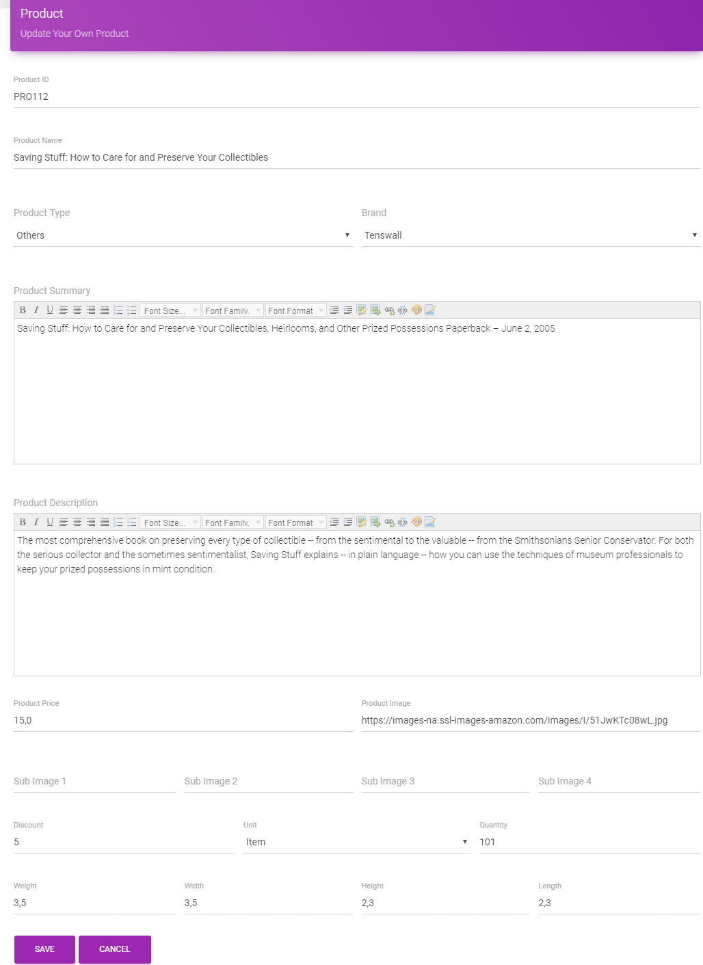

* + ***Description:***
* Link: admin/updateProduct.jsp
* This is page admin use to update product.
  + ***Validation:***
* Product name have 1-500 characters.
* Product Type, Brand selected from the list.
* Product Sumary can not be empty.
* Product Discount must be a number, from 0 to 100. (%)
* Price must be decimal number, min 0.01 and max 10000.
* Main Image URL required.
* Quantity required, min 0 and max 100.
* Weight required, min 0.01 and max 500.
* Width, height, length required, min 0.01 and max 1000.
* **Manage Category**
  1. **View, change category status**

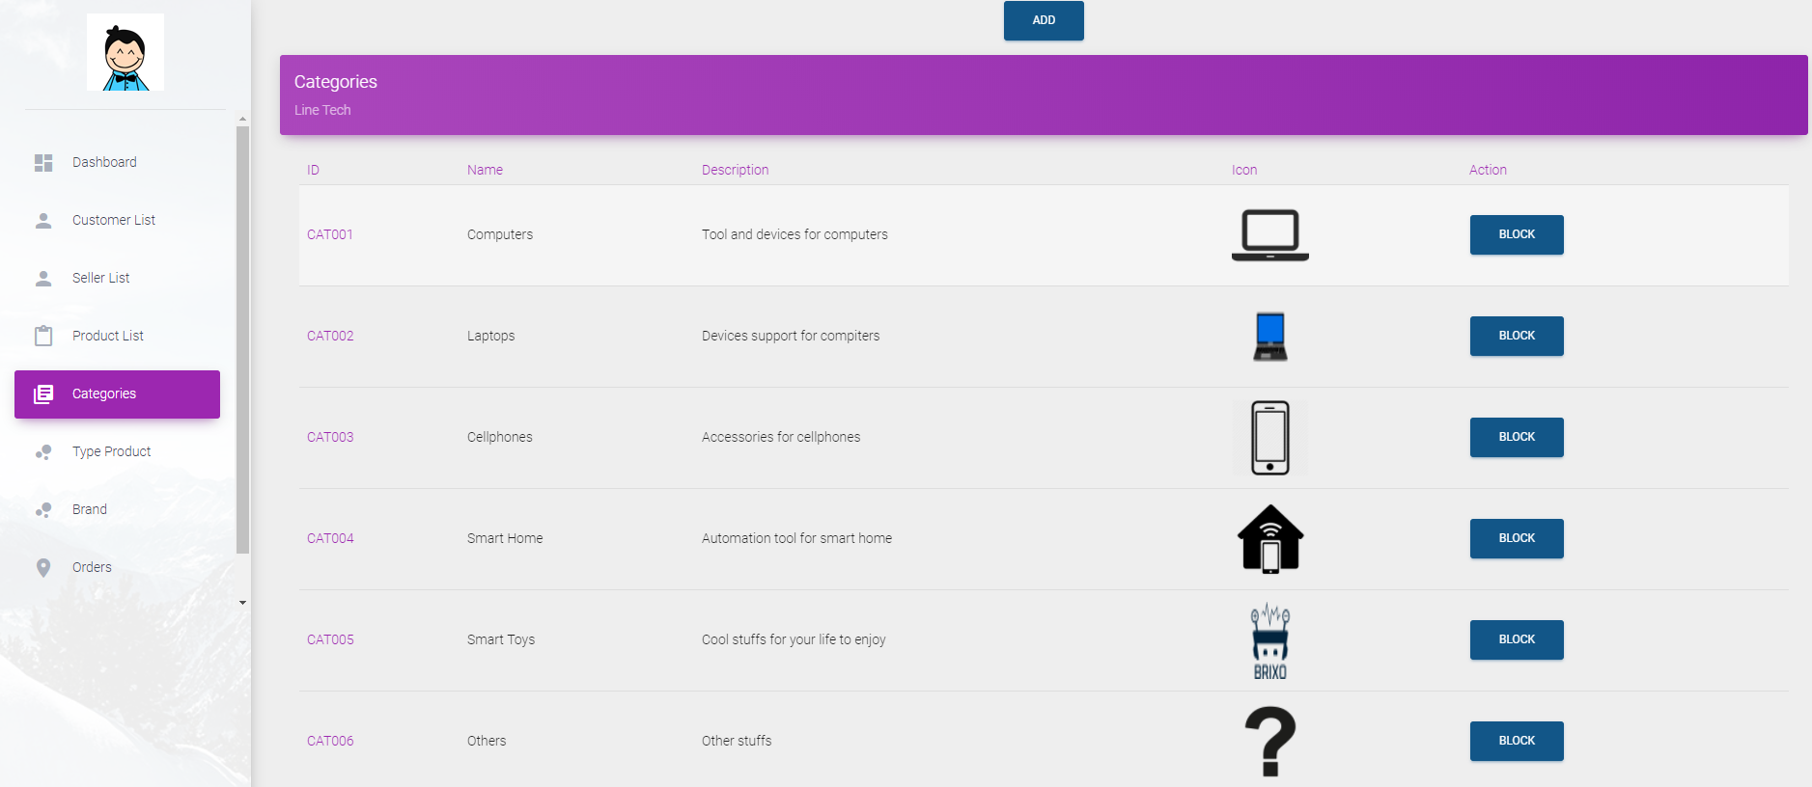

* + ***Description:***
* Link: admin/categories.jsp
* This is the page admin use to manage category.
* Admin can view category list.
* Admin can block/unlock category.
  + ***Validation:***
* Block type: If category have any product which is active, cannot block category.
* **Add a new category**

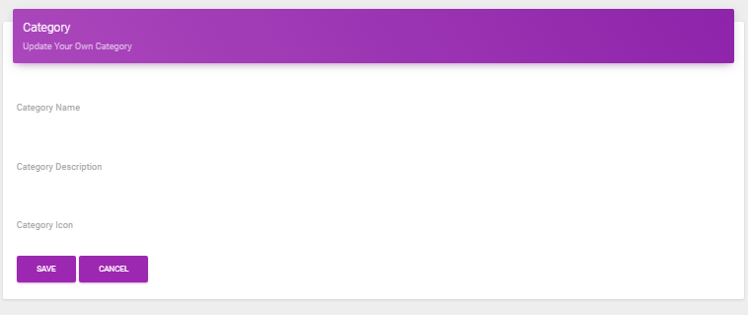

* + ***Description:***

1. Link: admin/addCategory.jsp
2. This is page admin use to add a new category.
   * ***Validation:***
3. Category name have 1-100 characters.

* **Update category**

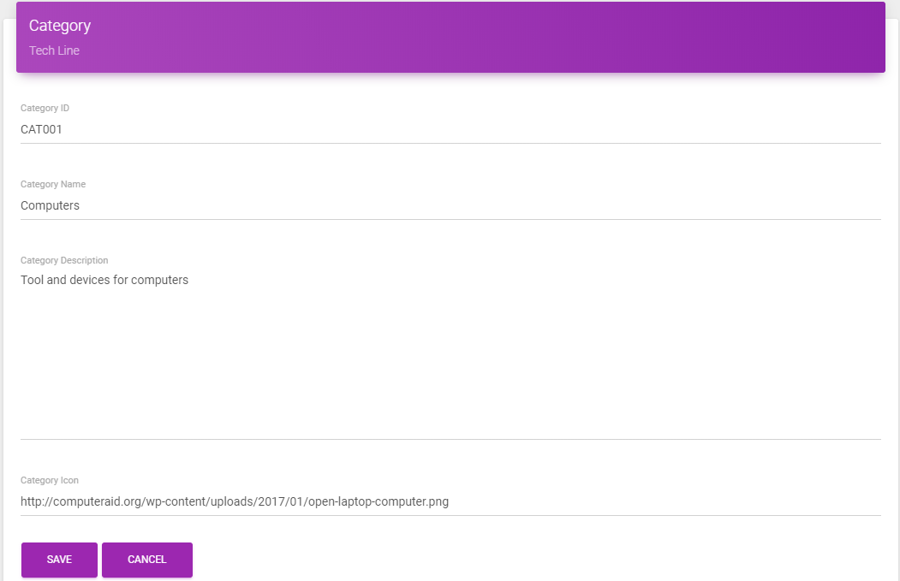

* + ***Description:***
* Link: admin/updateCategory.jsp
* This is page admin use to update category.
  + ***Validation:***
* Category name have 1-100 characters.

1. **Manage Product Type**
   1. **View, change product type status**

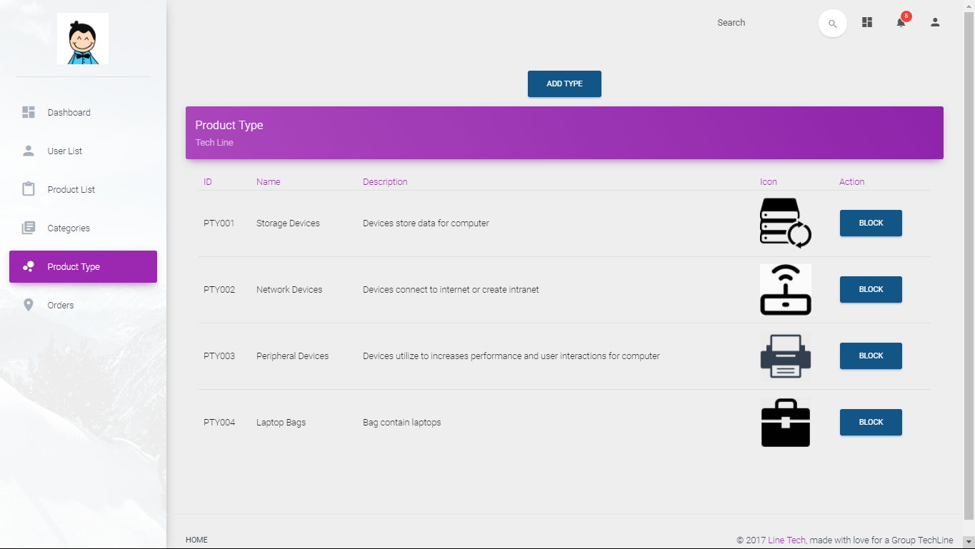

* + ***Description:***
* Link: admin/type.jsp
* This is the page admin use to manage product type.
* Admin can view product type list.
* Admin can block/unlock product type.
  + ***Validation***

1. Block type: If type have any product which is active, cannot block type.
2. Unblock type: If category of type is blocked, cannot unblock type, admin must unblock category or change category before unblock type.
   1. **Add a new product type**

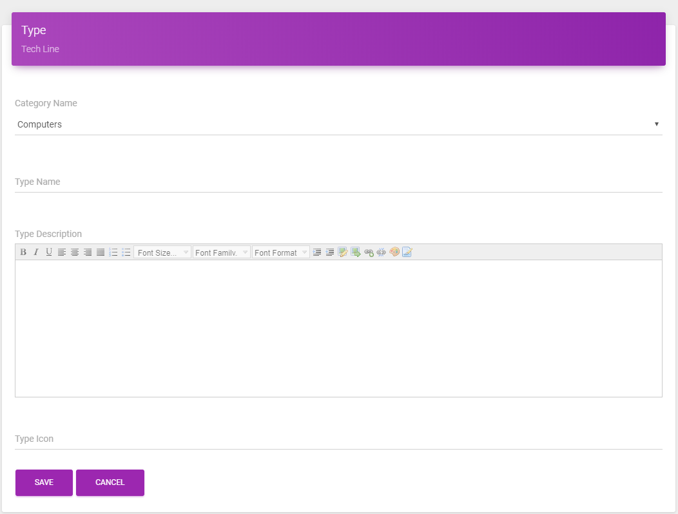

* + ***Description:***
* Link: admin/addType.jsp
* This is page admin use to add a new product type.
  + ***Validation:***
* Type name have 1-100 characters.

1. **Update product type**

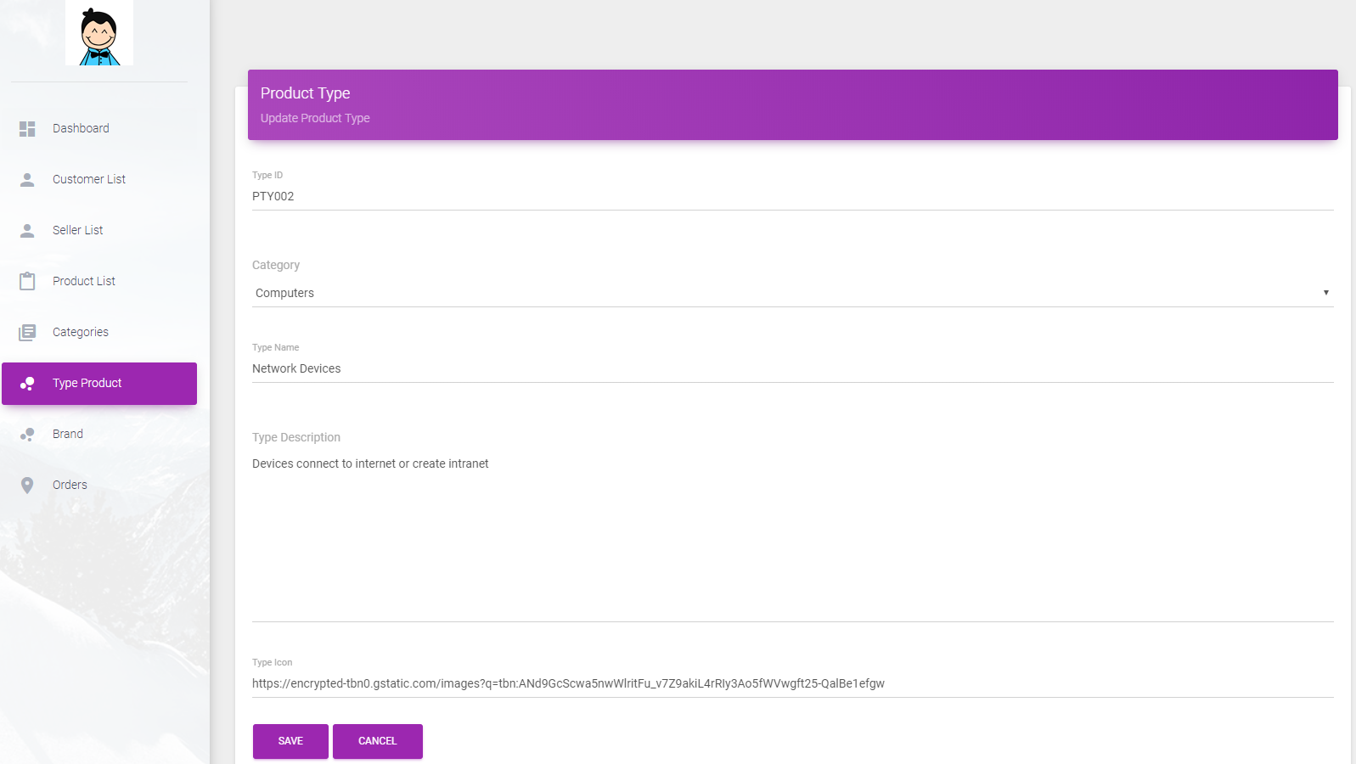

* + ***Description:***
* Link: updateCategory.jsp
* This is page admin use to update category.
  + ***Validation:***
* Type name have 1-100 characters.

1. **Manage Brand**

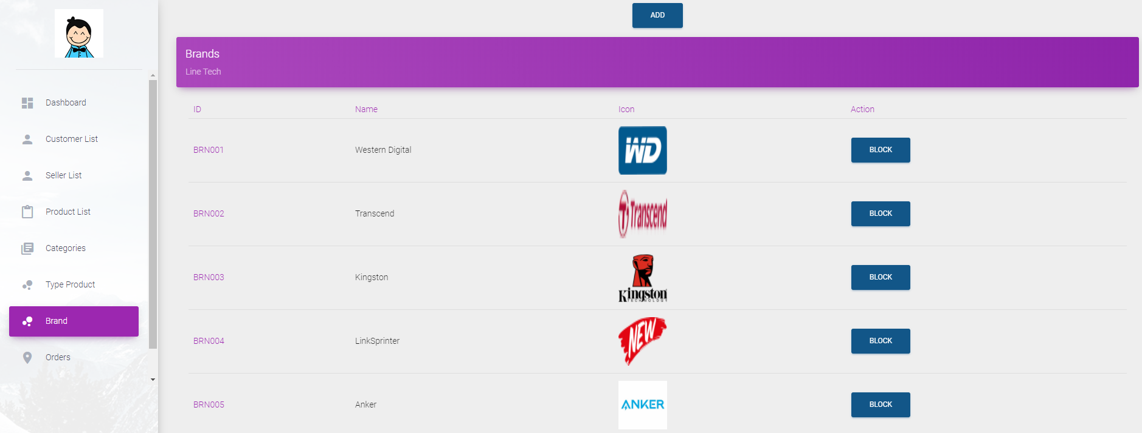

* + ***Description:***
* Link: admin/brand.jsp
* This is the page admin use to manage brand.
* Admin can view product brand list.
* Admin can block/unlock brand.
  + ***Validation***
* Block type: If type have any product which is active, can not block brand.
  + 1. **Manage Order**

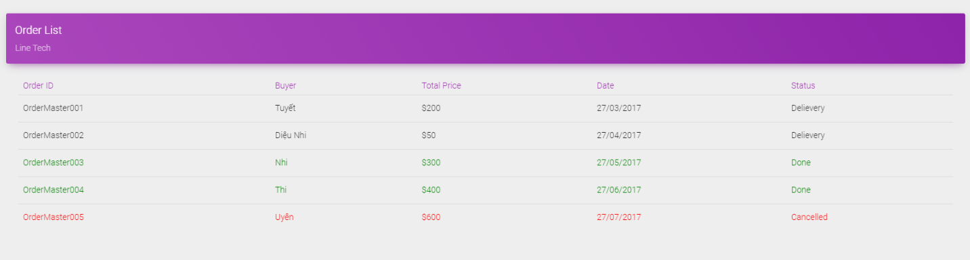

* + ***Description:***
* Link: admin/order.jsp
* This is page admin use to manage order.
* Admin can view order list.
* Admin can cancel order.
  + 1. **Report Product**

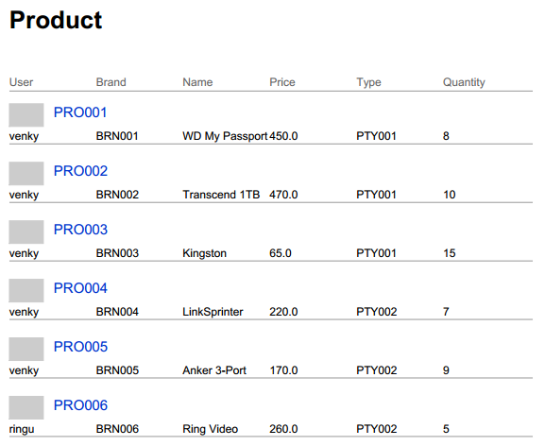

* + ***Description:***
* Link: admin/report.jsp
* This is page admin use to create a jasper report.
* Admin can view report about all products.
  + 1. **Report User**

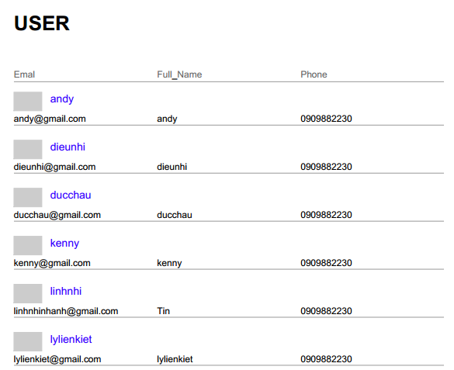

* + ***Description:***
* Link: admin/report.jsp
* This is page admin use to create a jasper report.
* Admin can view report about all users.
  + 1. **Report Order**

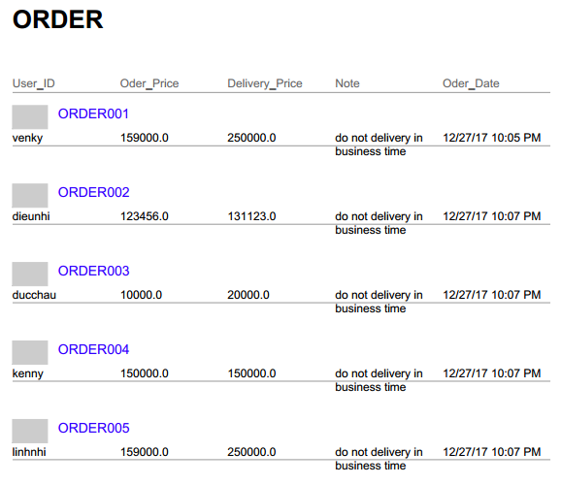

* + ***Description:***
* Link: admin/report.jsp
* This is page admin use to create a jasper report.
* Admin can view report about all order been placed.
  1. **Seller**
     1. **Manage Seller Information**

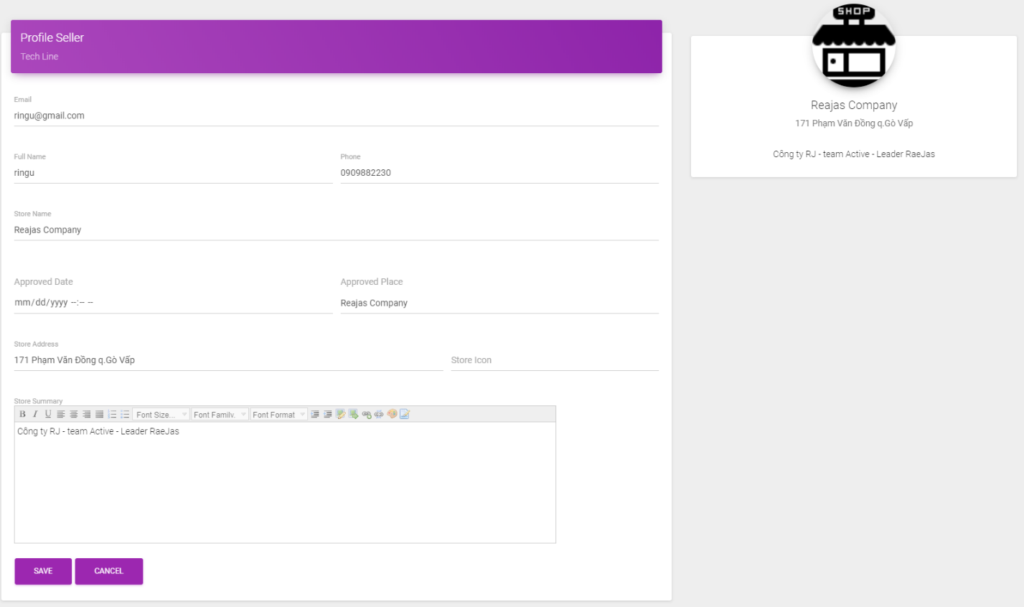

* + ***Description:***
* Link: seller/myAccount.jsp
* This is page seller use to manage their account.
  + ***Validation:***
* Full name, Store name cannot be empty.
* Phone have 10-11 digits.
* Email must be valid format.
* Address have 20 characters or more.

1. **Manage Product**
   * + 1. **View , change product status**



* + ***Description:***
* Link: seller/product.jsp
* This is the page seller use to manage their product.
* Seller can view product information.
* Seller can change product status.
  + - 1. **Add a new product**



* + ***Description:***
* Link: seller/addProduct.jsp
* This is page seller use to add a new product.
  + ***Validation:***
* Product name have 1-500 characters.
* Product Type, Brand selected from the list.
* Product Sumary can not be empty.
* Product Discount must be a number, from 0 to 100. (%)
* Price must be decimal number, min 0.01 and max 10000.
* Main Image URL required.
* Quantity required, min 0 and max 100.
* Weight required, min 0.01 and max 500.
* Width, height, length required, min 0.01 and max 1000.
  + - 1. **Update product**



* + ***Description:***
* Link: seller/updateProduct.jsp
* This is page seller use to update product.
  + ***Validation:***
* Product name have 1-500 characters.
* Product Type, Brand selected from the list.
* Product Sumary can not be empty.
* Product Discount must be a number, from 0 to 100. (%)
* Price must be decimal number, min 0.01 and max 10000.
* Main Image URL required.
* Quantity required, min 0 and max 100.
* Weight required, min 0.01 and max 500.
* Width, height, length required, min 0.01 and max 1000.

1. **Report Product**

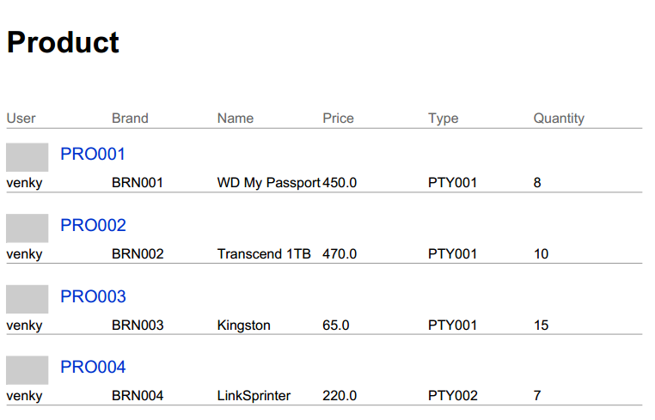

* + ***Description:***
* Link: seller/report.jsp
* This is page seller use to create a jasper report.
* Seller can view report about all products they are selling.

1. **Report Order**



* + ***Description:***
* Link: seller/report.jsp
* This is page seller use to create a jasper report.
* Seller can view report about all order they had from customers.

1. **Checklist of Validation**

|  |  |  |
| --- | --- | --- |
| **STT** | **Function** | **Check** |
|  | All numeric values default to 0 | **🗹** |
|  | Admin has all access to add and delete data | **🗹** |
|  | Data type is included in the database | **🗹** |
|  | All components are fully integrated and usable | **🗹** |
|  | All design standards have been applied | **🗹** |
|  | User interface is consistent | **🗹** |
|  | Is the flow between paths on the page accurate? | **🗹** |
|  | Have all the pages completed the error message? | **🗹** |
|  | All code run successfully | **🗹** |

1. **Submission Checklist**

|  |  |  |  |  |  |
| --- | --- | --- | --- | --- | --- |
| **STT** | **Detail** | **Yes** | **No** | **NA** | **Comment** |
|  | Are all managers able to find what they want? | Yes |  |  |  |
|  | All old data is stored and retrieved when required? | Yes |  |  |  |
|  | Are all components fully integrated and usable? | Yes |  |  |  |
|  | The user interface is no typo? | Yes |  |  |  |
|  | User-friendly application? | Yes |  |  |  |
|  | File installation project has been completed? | Yes |  |  |  |

E. **Review III Tasksheet**

|  |  |  |  |  |  |  |  |
| --- | --- | --- | --- | --- | --- | --- | --- |
| No. | Member | Content | Page | Plan | Implementing period | | |
| Start date | Real start | Real day | Status |
| 1 | Nguyễn Thế Huân | * View Product, Category and Type * Add, Edit, Remove Product in Cart * Rating , discount on products. | Index, Product Detail | 15/12/2017 | 27/12/2017 | 12 | OK |
| 2 | Nguyễn Minh Tiến | * Build google map for user to choose delivery destination. * Place an order * Manage Order * Discount on Order | Order | 15/12/2017 | 27/12/2017 | 12 | OK |
| 3 | Cung Đình Uy | * Add , Edit, Delete Product, Category , Type, Brand as Admin role * Search Product. * Create chart for admin dashboard | Admin | 15/12/2017 | 27/12/2017 | 12 | OK |
| 4 | Trần Khánh Vương | * View, Add, Edit User ‘s Information * Add, Edit, Delete Product as Seller role. * View Jasper Report | Register, Seller | 15/12/2017 | 27/12/2017 | 12 | OK |

**Instructor**

**Phan Minh Tâm**